

Project Management Guide

Chapter Name: North Columbus Jaycees State Name: Ohio
Project Name: Jaycee Ultimate Mentorship Program
Area of Opportunity: Community
Category: Local Community Empowerment Program

PLANNING
- Primary Purpose

This project directly targets homeless and near homeless middle school students to teach lessons about the power of a positive attitude, career based skills, professional skills, life skills, and overcoming adversity. It is the goal of this program to provide more skillful owners and employees, communities with involved citizens, and government with knowledgeable members and participants.

- Project Overview
  - Give a brief description of the proposed project and background information.

In 2017 according to ICPH (Institute for Children, Poverty & Homelessness) there were 27,939 homeless students in Ohio, making up 1.6% of total enrollment with some school districts in the state having up to an 18% homeless student population. This issue effects every school district regardless of the areas perceived wealth and sometimes due to stigma and shame it is more difficult for students in more affluent areas to seek and receive the help they need.

The purpose of this project will be to work with the Buckeye Jaycee Foundation to provide a mentorship & training program to underprivileged student’s grades four and five located in the Columbus City School System. The mentorship program would consist of the following; lessons about attitude, teaching career based skills, professional skills, life skills, and overcoming adversity.

We believe that there are many components of helping a child in an underrepresented community succeed. The first component is that in order for them to be able to effectively learn, they must be nourished properly. Most of the students targeted in this program are lucky to have one meal a day and on weekends and days without school provided meals they may not eat at all. This program will also help to develop a positive attitude in these students. The majority of them feel like they have been dealt a "bad hand", and there is no denying some of them have. We must encourage them that they can make a better life with education, persistence, pride in their work, and good work ethic.

  - How will this project benefit the individual member, the chapter, and the community?
Members will have the opportunity to build this project from the ground up giving them experience in numerous leadership areas including but not limited to:
- Project planning
- Relationships with community leaders, school staff, and other organizations
- Speaking and leadership experience when dealing with underserved youth
- The experience of seeing a hugely impactful social program from start to finish inspiring confidence and follow-up projects

The North Columbus Jaycees as a chapter will benefit from the relationships we will be building with likeminded organizations such as Reeb Center, Driven, MidOhio Food Bank, Columbus Public Schools, etc. Dealing with organizations that have goals parallel to our own will also afford us the opportunity to recruit more socially aware members. This program will give our chapter the foot in the door and some of the name recognition to expand our ideas and partnerships for other community building and empowerment programs. One of the main goals of this program is being able to reproduce it at other schools effected to various levels with the same issues. This project will give our members and associates the skills, knowledge and confidence needed to become better leaders. Ultimately helping to complete the student to teacher circle of education needed to sustain the chapter in producing the board members and presidents of tomorrow.

Providing the interaction and services outlined in this program will give this under represented demographic of our community the education, confidence, and some assets to make them a powerful and more compassionate member of tomorrows government, entrepreneurs, managers, employees, and all around better members of our neighborhoods and infrastructures. It is our sincere hope that by explaining to the students the processes of getting this from an idea to a fully functioning project as well as our encouraging them to be involved in their community they will become more community oriented and this will snowball into very involved and thus safer and better served communities.

An added bonus to both the chapter and the community is the awareness of the issue by the local business community and charitable organizations. The act of securing funding and resources will by its nature put the issue and the Jaycees in front of a lot of owners, managers and people in the community, some of which will be able to contribute and others that may be able to contribute to future projects run in this area. Our community involvement hopefully will spawn some grassroots projects not associated with the Jaycees but servicing the same segment of society we are looking to help.

  - List specific and measurable goals to be accomplished by this project.

    - Goal 1 – 80% student attendance
Students program attendance is a crucial part of the success of this project. Students will be required to attend 80% of the classes to complete the course. Program attendance will be taken and tracked every class.

    - Goal 2 – Behavior and confidence
We will work with staff at the shelter and family if available as well as our own volunteer’s observations. This information will be used to determine if the advice given by the lessons and speakers is being absorbed and applied and so we can adjust our techniques accordingly.

    - Goal 3 – School attendance and grades
Students grades and school attendance will be collected and logged throughout the program. We will discuss the importance of these with the student.

    - Goal 4 – Partnering with at least three other organizations or business
Enlisting the help and experience of other likeminded entities will help bolster our name and hopefully numbers in the community. This will also afford us the opportunity to learn from others with experience in the areas we are look to work in.

    - Goal 5 – Include 10 chapter members in the planning and execution of the project
To ensure the North Columbus Jaycees reap the full benefit of the lessons we will learn while planning and running this project and can pass this experience on to future chapter members it is important we take a very hand on approach and work beside other leaders and advisers and not behind them.

    - Recruit three new members to the chapter from volunteers
This project is going to require a lot of mentorship and help from other organizations more familiar with the hurdles we need to clear to see it thru successfully. Working with the community leaders will afford us the opportunity to get them involved with the chapter.

- Steps to implementation: List the specific steps to bring this project to a successful completion, showing the planned dates for each step, and the person or people responsible for each step.

TASK/ACTIVITY | START DATE | FINISH DATE | % COMPLETE | PERSON(S) RESPONSIBLE | CRITICAL TASK (Y/N) | FOR CRITICAL TASKS:
 |  |  |  |  |  | POTENTIAL PROBLEM | POTENTIAL SOLUTION
Submit PMG to Buckeye Jaycee Foundation | 4/20/18 | 5/2/18 | 100% | Greg Thirtyacre | Yes
Find School to partner with | 4/20/18 | 8/7/18 | 100% | Greg Thirtyacre | Yes
Find local restaurants for meal donations | 4/20/18 | 12/14/18 | 90% | Greg Thirtyacre | Yes
Select 20 students best suited for this program | 8/7/18 | 12/14/18 | 75% | Mr. Jones (Principle) | Yes
Curriculum and program flow | 8/7/18 | 12/14/18 | 100% | Ashley Gose | Yes
Securing a nutritional food source | 4/20/18 | 12/14/18 | 100% | Antowne Brown | Yes
Training for mentors and experienced advice | 4/20/18 | 12/14/18 | 100% | Rich Galzarano | Yes

- Critical Contacts
Chairman
Name: Greg Thirtyacre III
Position: Chapter President, Vice President of Buckeye Jaycee Foundation
Email: Thirtyg@gmail.com
Phone: (614) 206-1394
Duties: Oversee project and ensure all obligations are fulfilled

Committee Member – Organizing Director
Name: Rich Galzarano
Position: Chapter Vice President, President of Buckeye Jaycee Foundation
Email: RGalzarano@gmail.com
Phone: (216) 543-1640
Duties: Locating advisors and providing his experience, Mentoring, Speaking, Serving.

Committee Member – Technology Director
Name: Ashley Gose
Position: Chapter Chairman of the Board, Secretary of Buckeye Jaycee Foundation
Email: Goseae@hotmail.com
Phone: (309) 825-1587
Duties: Curriculum, Preparing and maintaining the tablets, Mentoring, Speaking, Serving.

Committee Member – Logistics Coordinator and Director
Name: Antwone Brown
Email: Bantwone231992@gmail.com
Phone: (614) 255-5067
Duties: Shopping and meal prep, Mentoring, Speaking, Serving.

Committee Member – Director (new member)
Name: John Thirtyacre
Email: N/A
Duties: Setup, Mentoring, Speaking, Serving.

Committee Member – Director
Name: Eric Shook
Email: MadTinkerer@gmail.com
Duties: Setup, Mentoring, Speaking, Serving.

- What specific materials, supplies, and resources will be required?

Material or Supply & Quantity | Person Responsible for Obtaining | Date Needed | Donated, Owned or Purchased? | Cost/Value
Tablets for students | Greg Thirtyacre | 8/7/18 | Purchased | $2,000
Meals for students/volunteers | Greg Thirtyacre | 8/7/18 | Donated/Purchased | $3,000
Food for students to take home | Antwone Brown | 8/7/18 | Purchased | $2,400
Transportation of food and supplies | Greg Thirtyacre | 8/7/18 | Donated | $1,000

- Complete a proposed budget indicating all anticipated income and expenses

Proposed Budget
INCOME: PROPOSED
Appropriation from chapter $0
Value of donated items (list)
Meals $3,000
Food to send home $2,000
Location to hold project $1,200
Certified instructor to oversee students and curriculum $900
Other sources of income (list)
Grant money through Buckeye Jaycee Foundation $10,000
__________________________________________
TOTAL INCOME $17,100

EXPENSES: PROPOSED
Value of donated items (list)
Meals $3,000
Food to send home $2,000
Other expenses (list)
Computers and Technology $4,375
Office supplies $225
Printing $100
Training $1,500
Travel $900
Other direct cost $2,900

Return of appropriation from chapter $0
Return to chapter (profit) $0
__________________________________________
TOTAL EXPENSES $10,000

- Describe the potential problems and solutions to successfully complete this project.

Potential Problem: No school/shelter to partner with
Potential Solution: Perseverance. Speak with local organizations that already do this type of work, there is no reason to reinvent the wheel. Most programs like this are offered to the school for a fee so coming with a funded program will make us valuable to someone. A big asset in this is being able to present the school/shelter with a clear, measurable and manageable goals and complete plan on how you intend to reach these goals. Also be upfront about any cost (time, resources, funding, staffing, etc.) that you will require from them. Most of all be genuine and transparent on your intent and passion to complete a successful program. If the group you are seeking to partner with is unable to work with you don’t be discouraged but do ask them why they are unable to work with you so that when approaching other potential partners you can address the issues.

Potential Problem: Not enough students
Potential Solution: Partner with a school/shelter large enough to fulfill our goal of 20 students. Come up with a clear plan working with the staff of the participating on sourcing and reaching over 20 students to account for the parents/students that are unable to participate (don’t only offer the program to 20 student). It is also important to make sure the students are in fact in need of the program and are not just there for free babysitting. This can be a touchy process and you should work with the school/staff to identify who would “be best served by this type of program”. If you put out permission slips/sign ups to all of the students, you will inevitably get back a lot of students that are not your target demographic and are just looking for something to do or parents are looking for a free babysitter. Wording is also very important. When working with the public school system you are not permitted to use the word “homeless” as it is discriminatory to students with homes. It is important to use the phrasing “underprivileged” and to let the school/staff help to determine the meaning of this word as it pertains to their school/shelter.

Potential Problem: Not enough funding/donations
Potential Solution: As this is the first run of the program there are bound to be shortfalls and overages in different line items on the budget. (All funds garnered from the ECMC grant must be spent on what they were specified for within 10%). Work throughout the whole program to find donations for any short coming, this could involve soliciting restaurants for food both for “Snack” and food to be sent home. Exploring the possibility of working with other originations that already fulfill one of the needs we need me and utilizing the service they already provide (foodbank, Art programs, Books, Etc.)

**When approaching a potential donor be sure to have your goals and how you are going to reach them as well as dates and times of the program printed and on hand. Offer a copy and be familiar with the program and ready to point out examples addressing their concerns. Organizations/people are hit up daily for donations, having a clear game plain and knowing exactly how their donation will be used/spent will give you a huge advantage. Also even if they are unable to support you with a donation ask them to get involved with the program. Find out if they or any of their employees would like to volunteer or if they are appropriate for the position ask them to be a speaker for one of the days. **

Potential Problem: Finding qualified mentors
Potential Solution: All mentors should be willing and able to pass a background check (Required if working with a school and also an expense you will need to figure into the budget). All mentors should also be responsible and reliable enough to show up on the designated dates and times with minimal reminders. Start looking for members within the chapter (North Columbus Jaycees) first, and then expand the search to other Jaycee chapters and likeminded organizations. Utilize the mentors recruited in suggesting and searching for other individuals they feel confident would be responsible enough to fill the need. Recruit volunteers from within the School/Organization you are partnering with, these volunteers will already know the students/participants and will also have a working knowledge of the facility and staff.

Potential Problem: Filling each date with a speaker
Potential Solution: Again, Perseverance! speak with local organizations that already do this type of work. Approach local business owners and politicians. Reach out to likeminded organizations (Young Professionals, Rotary, Kiwanis, etc.). Task the people you trust as mentors to suggest/solicit people they know to be qualified. Be clear when approaching potential speakers on what you want them to speak on and how long they are expected to speak as well as who their audience will be.

When out soliciting donations be sure to ask, many business owners love the opportunity to tell their story. It may turn out that they are unable to make the program due to date and time issues but them telling the story to you, which they will, helps them see how important the program is and just how close it can hit to home securing a donation or help you may not otherwise have received.

Potential Problem: City and district red tape
Potential Solution: Accept that there is going to be a lot of red tape when initially starting a project like this and don’t be frustrated/discouraged by it. Start locally (school/shelter staff) and follow their instructions. You will most likely be referred up many different chains of command for different reasons. An example of this is being referred to district or city administration to verify this program and volunteers are qualified to work with children, being referred to a nutritionist to ensure the food you are feeding the children is responsibly sourced and safe and handled properly, referred to teachers or guidance counselors to ensure the curriculum you will be teaching the children is appropriate, etc.

Potential Problem: Lack of involvement on school/organizations behalf
Potential Solution: It is important when searching for a school/organization to work with that they are 100% on board and are willing to help you work through the inevitable road blocks, red tape, and daily issues that will arise. While you ultimately will be the one responsible for the program their assistance, connections, and advice will be priceless. Be sure that the school/organization shares your goals and is not just looking for a handout or autonomous program. Make sure they are aware that we are by no means experts or sometimes even laymen in this area and that their assistance is crucial to the success of the program. Do not commit to anything until you are sure of this, going at this alone will make everything more difficult including cutting the red tape, sourcing the participants, handling issues with the children that may arise (fights, acting out, crying uncontrollably, etc.).

I cannot stress enough how important it is to work with a school/organization/staff that shares your program’s goals and is willing to put in the work with you. Doing all of this yourself will result in a logistical nightmare and impossible amount of side task taking away from your ability to reach the set goals.

Potential Problem: Unruly kids
Potential Solution: Have one person in control of the program and keeping the kids on track, make sure they are always the one in charge to maintain consistency. When having multiple people in charge it confuses the message and who the students should be taking directions from as well as allows them to play mentors against each other. This person should be able to clearly state what the kids need to be doing at that time (eating, homework, getting ready to leave, etc.). This person will not be very popular with the kids but they will listen to them (bad cop). It is also key to work with staff who know the kids and their individual behaviors and needs as well as are able to discipline and speak with the parents if need be. I cannot stress how important it is to always let the staff deal with any disciplinary issues and to break up any physical altercation that may take place. You do not want to open yourself to any undue liability.

Potential Problem: Food and asset logistics
Potential Solution: Sourcing, obtaining, transporting, sorting, and staging assets is a very large part of the program and is crucial to the success thereof. Finding reliable volunteers who are willing to donate their time, vehicles, and gas is not easy and requires someone with a passion for the project. You may offer to reimburse this person or people for their gas used. This part of the project requires just about daily interactions with stores, foodbanks, restaurants, partners, etc. It is best practice to put one person in charge of this and allow them to partner with or delegate responsibilities to other willing volunteers, many hands make light work. It is also key to make sure consistent and tested practices are used when dealing in this area (being at the foodbank before they open to guarantee the best products available that day, waiting until the day of to purchase/source perishable goods so they are as fresh as possible, working with restaurants to assure the food can be picked up, transported, and served in a manner that follows accepted safe handling temperatures and producers, etc.).

Potential Problem: Documentation for grant and repeatability
Potential Solution: Keeping track of everything is important to the sustainability and repeatability of this project. This involves but is not limited to keeping track of finances, attendance of students and volunteers, documentation from background checks and any certificates or exceptions, documentation of speakers and subjects, documentation of any issues that arise logistically or from student behavior, etc. This also includes minutes from any meetings and notes from any trainings. This is a key role and should be filled by someone who has their own passion and drive for the project.

Potential Problem: Sensitive political, racial, economic, or religious subjects
Potential Solution: Unless the program is specifically designed to discuss and deal with one of these subjects it is best to avoid letting them take the spotlight. These subjects can lead to a division or discrimination of the students and parents and may result in them withdrawing from the program or taking legal action. In some circumstances it is necessary to address one or more of these issues, it is best to bring in someone knowledgeable of the issue and approved by the school/shelter to address the subject. This partially removes you from liability and shows that while the issue may be sensitive, that it was addressed with the proper respect and reverence due.

Potential Problem: Parents not happy with service provided to children
Potential Solution: It is important to get the parents input and suggestions whenever possible to make sure we are fulfilling the need present. In the case the parents are not pleased with the service provided take the time to hear them out and understand what needs need to be met and how you could best meet them in their eyes. While this may not be a procedure/lesson you institute it will help you understand that point of view and may help ease other parents concerns too. It is important to keep in mind that what we perceive as a need may in fact not be the biggest need. The parents and students are the ones on the frontlines so to speak, they are experiencing the hardship we are trying to help with. It’s important their opinion is not only heard but thought and if needed acted upon. It is also possible that after attending the program they realize that it provides assistance that is not needed by that particular family. In this case there is no shame on the parents or the programs part in withdrawing them from the program and seeking a new family/student who will be better served by what the program has to offer.

EVALUATION

- List solutions and/or recommendations for future Project Managers.

- One of the most important things I can pass on is to segment the curriculum and activates and make them modular. This will allow you and your volunteers to deal with logistical and behavioral needs on the fly. An example of this is if the food is running late you may choose to have the students do their homework module thus allowing extra time for the food delivery and staging. Also allow 10-15 minutes of “activity” at the end of the program. This will allow you some buffer time to be used to get the kids ready to go, pass out food, or just play a game of heads up seven up and won’t put you in a situation of cutting other curriculum short if you fall behind schedule or if the parents show up early.

- We found that the students listen to the speakers more attentively if they are eating or just finished eating. At the onset of this program we had the students eat their “snack” for 30 minutes, work on homework with their mentors for 20 minutes, then listen to a speaker followed by Q&A for 20 minutes. Three or four sessions into the program we found that some students were continuing to work on homework or using their paper and pencils to distract them while the speaker was still speaking. By moving the homework module to the beginning, followed by “snack” and a speaker they paid more attention to the speaker and their message. We also found that overlapping the speaker so that they start in the last 10-15 minutes of the “snack” module so that they were speaking while the students were still eating helped them to focus on the speaker.

- Something that deserves stressing is that this project is very rewarding, but is almost an overwhelming amount of work. Prior to and during the program it will require daily prepping and running around on multiple fronts. Many of the task need to be completed during normal business hours which may require chairmen and volunteers to take time off of work. If you have enough committed volunteers some of the responsibilities like shopping for food, going to the food bank, soliciting business for donations, etc. can be delegated but should be monitored (it’s a big deal when the food doesn’t show up).

- Persistence is key to this whole project. When looking for donations, trying to find volunteers, even looking for schools or organizations to partner with you are going to get a lot of people telling you no and they are going to give you a lot of different and unique excuses. In my personal experience as chairman of the program I feel like I got 3 or 4 people that were unable to assist the program for every one person able to donate their time or services. Full disclosure at first this was very frustrating and made me feel like the program was not going to be a success. I then made it my goal to solicit 4 business every day on top of the other responsibilities of the program. Just by the law of statistics this led to more people committing to helping us and bolstered my and others morale.

- One trick I can share that I found helpful when soliciting restaurants for food donations for the “snack” was to be seated and order a meal (sometimes I would eat 2 or 3 small lunches a day), be sure to go in at a time when they are not busy so you will get more attention. When the waitress/waiter bring the meal/appetizer out look it over and then ask to speak to the manager. When you just walk in and ask for a manager they assume you are trying to sell them something or hitting them up for a donation often resulting in them coming back out to tell you the manager is busy but they will get in touch if you leave your email of phone number… which never actually happens. But if you request to speak with them after spending money and looking over your food they will come out to see you every time because they assume you are not pleased with the order.

Once they come out let them know that the food and the service has been wonderful and that you would like to talk to them about an afterschool program you are looking to start in the local community. Have a copy of the program goals, modular schedule of curriculum, dates and times of the program, speakers and their topics, and most importantly be able to show them what other restaurants in the area are donating and what dates they are donating on. One thing I discovered is that the owners/managers want to know if their competition is doing it and if they are I was more likely to get a donation from them as well. I know I mentioned it earlier in the PMG but managers and owners love to talk about their story. When you share information about the program they will almost always relate and tell you the story of how they started as a dishwasher or hostess. This gets them emotionally involved in the project and will bolster the odds that they will donate. Be confident and know the program so you can quickly address any of their concerns.

- Make sure to get all commitments in written form, email works great for this though I would highly recommend first contact be face to face. The different and repeated deadlines and constant adaptations due to unforeseeable events can be overwhelming to keep track of and it is important to be able to keep track of and follow up to confirm commitments.

- Work with the school/organization on a schedule as a first step before planning meals, speakers, and curriculum. We ran into lots of obstacles like early dismissal, parent teacher conferences, teacher in-service days, etc. These required us to move dates in some cases and in others to skip that week all together. Be flexible in your planning and have a backup plain the switch to at any moment.

- Results

Primary Purpose:
This project directly targets homeless and near homeless middle school students to teach lessons about the power of a positive attitude, career based skills, professional skills, life skills, and overcoming adversity. It is the goal of this program to provide more skillful owners and employees, communities with involved citizens, and government with knowledgeable members and participants.

Results:

With assistance from school office staff and teachers we were able to identify and include our target demographic of underprivileged 4th and 5th graders. Working with speakers and presenters weekly we were able to teach valuable lessons to the students. The students were able to not only participate in these activities but weeks later at the end of the program were able to recall the lessons and explain their importance, in some cases months after the speakers had taught the lesson. Particularly impressive was their recognition that in order to succeed you have to start from the bottom, be willing to learn, and put in the effort to become successful.

Goal 1: 80% student attendance
Students program attendance is a crucial part of the success of this project. Students will be required to attend 80% of the classes to complete the course. Program attendance will be taken and tracked every class
Result: Program records kept by the school office staff and verified by program volunteers showed of 162 possible student opportunities to attend there were only 28 absences, giving the program an 82.72% attendance rate

Goal 2: Behavior and confidence
We will work with staff at the school/shelter and family if available as well as our own volunteer’s observations. This information will be used to determine if the advice given by the lessons and speakers is being absorbed and applied and so we can adjust our techniques accordingly.

Result: In a majority of the students there was a noticeable difference in their behavior both during their attendance in the program and their day to day school life. Students who started the program shouting out answers to questions were raising their hands and waiting their turn to speak by the end.

Some students at the beginning of the program found it difficult to stay in their seats and remain on task. This was often displayed in their chattiness with other students and their constantly asking permission to go to their classroom or the bathroom. These issues were dealt with by only allowing them one bathroom trip, making sure the students had all the homework and items needed from their classrooms before they came down for the day, and separating students that were overly chatty with each other, allowing them to return to their group of friends if they could display the ability to sit quietly and stay focused.

Goal 3: School attendance and grades
Students grades and school attendance will be collected and logged throughout the program. We will discuss the importance of these with the student.

Result: This goal was monitored and reported to us by the school office staff, teachers, and by the students sharing their interim reports and report cards. One thing we are most proud of was the number of students in our program that qualified for school “officer” status. These were students who had earned the privilege to be a leader in their classroom through attendance, grades, and leadership qualities. Half way to completing our program we were informed by the principal that a very high number of our students had received this honor where they had not qualified for it at previously.

Goal 4: Partnering with at least three other organizations or business
Enlisting the help and experience of other likeminded entities will help bolster our name and hopefully numbers in the community. This will also afford us the opportunity to learn from others with experience in the areas we are look to work in.

Result: This project opened us up to partnerships with a lot of likeminded individuals, business, and organizations. Entities we were able to communicate and develop a relationship with include but are not limited to Northgate Intermediate School, Columbus Public Schools, Mid-Ohio Foodbank, Roosters, Pots-N-Pans, Chuy’s, Hot Chicken Takeover, The Melt Bar and Grill, Asian Festival Corp, Donato’s, South Side Roots, the Reeb Ave Center, The Free Store, Carsonies, Delaney’s, 1400 Food Lab, and many others. We were able to form a relationship with many of these entities that will last into future projects, a lot of them are already excited for our next opportunity for them to help fill a need in the community and will be partners going forward. We have also formed a bond with the staff and parents/students of the school we partnered with for this program. They have welcomed us back to their school for any other programs we would like to run as well as offered their help in identifying the needs in their community.

Goal 5: Include 10 chapter members in the planning and execution of the project
To ensure the North Columbus Jaycees reap the full benefit of the lessons we will learn while planning and running this project and can pass this experience on to future chapter members it is important we take a very hand on approach and work beside other leaders and advisers and not behind them.

Result: Throughout this program we were able to utilize the suggestions, skills, and time of over 14 current or new members of the North Columbus Jaycee chapter. This includes but is not limited to volunteers to be mentors, guidance and suggestions by current members who were too busy to commit their time to the program during normal working hours and thus could not be mentors, and assets members had or had access to through their family or workplace.

Goal 6: Recruit three new members to the chapter from volunteers
This project is going to require a lot of mentorship and help from other organizations more familiar with the hurdles we need to clear to see it thru successfully. Working with the community leaders will afford us the opportunity to get them involved with the chapter.

Result: The North Columbus Jaycees were able to recruit three new members solely because of this program (all three of which we have been actively working on getting to join for over a year). Part of this was due to the fact that we required all volunteers to be a chapter member and thus covered by our insurance to work directly with the students. None of these new members would have become members if they first didn’t believe in this program and secondly were not called upon as in their own sense of responsibility to the community and this group of underserved kids and families.

Project Summary:

This project went from being an idea four members had sitting around a table after a chapter meeting one night to a full-fledged after school program. This was overwhelmingly due to our volunteers and members desire to make a difference in our local community and the hard work and perseverance needed to do so. The program quickly took on a life of its own and although there were many roadblocks, all of them were worked through and new ideas and pieces of the project emerged from the challenges.

One of the goals of the program was to make sure the students were not only fed during the program but were also able to take home a meal or two for lunch or dinner later in the week. Through a partnership established with Mid-Ohio Foodbank and a considerable amount of help making funds stretch from Aldi, we were not only able to send home food for the students, but for their entire families. Some students even felt the calling to bring some of the lunch items we provided to school and share them with other students in need.

The best example of the project taking on a life of its own was the Secret Santa activity we were able to provide the students on the last day (December 14th) of the program. A group of nurses from Ohio State University Hospital led by approached me via a new member (Elizabeth Thirtyacre) that signed up specifically to be a mentor with this program. This group of nurses requested clothes and shoe sizes as well as a suggested gift list (attached) completely unsolicited because they felt called upon to fill a need. Working with the students to provide a list of items under twenty dollars, each student was able to receive almost everything they had requested. This all was procured and paid for by the nurses at OSU and came with a request to let them know if we ever do a project like this again so they could offer more help.

Over the course of the 12-week program we brought in different speakers to talk about their profession and how hard work and perseverance payed off for them and others in their line of work. We wanted to make sure the students understood that a lot of careers do not always require an unaffordable college education. The general Manager of Chuy’s best made this point to the students I believe. She told them that with hard work, passion, and persistence not only did she go from washing dishes to being the youngest GM in the history of the company, but she did it all without going to college. She also told the students the history of the Chuy’s franchise which stuck with them a lot better than we expected. On the final day when reviewing all of the speaker’s lessons with the kids they were able to recall that a dish washer and a bus boy with hard work, determination, and no college attendance were able to start a multi-million-dollar restaurant chain.

Donato’s also brought in a presenter that did an activity with the students involving the different positions in their business and the chain of command/profit. They gave one student (the customer) $20 and had them buy a pizza. Then the student portraying the manager divided the money amongst the other students acting as suppliers, employees, government, insurance, advertising, etc. Teaching the students career based and life skills in what turned out to be a very memorable lesson for the students.

Project Benefit :

Individual Impact: This project has benefited our chapter members, volunteers, school staff, and students in far more ways than were envisioned and then can be listed here. For starters others and myself were nervous about working with children of this age, out of lack of experience we simply didn’t know what to expect. Working with the principle and other school staff we soon realized our worries and potential road block was all for nothing. This program also gave us all a healthy respect for the challenges facing not only school staff but also the hardships low or no income households in our own neighborhood have to endure on a daily basis, helping us to better understand the plight of our own community.

While opening our eyes to the situation we also were making connections in the school and community. We forged new alliances and friendships with other organizations and business owners which I will mentioned throughout this document, but connections that all of us individually can work with in upcoming projects and personal conquest in the Columbus area.

Chapter Impact: Aside from the obvious impact of signing three new chapter members this project served many other benefits to the chapter as a whole. By partnering with other organizations and businesses in the area and with approaching the school board and even different city council and senate members with questions and request we have greatly increased our name recognition in the Columbus area. This along with successfully completing the project by every measure given to us not only gets our name in front of these influential people and organizations, but our successful completion of the project shows them that we complete what we set out to do and can be counted on for results, thus opening the door to larger partnerships down the road.

This has also served to bring our chapter closer together, activating some members that had not been showing up to meetings or had otherwise fallen off the map, even causing one of them to settle unpaid membership fees and renew their dormant membership to the chapter. By solving problems on the fly as a group we strengthened our chapter’s camaraderie, size, involvement, and income along with other aspects all at the same time.

From this project we have also formed an alliance with Mid-Ohio food bank, The Free Store, Reeb Avenue Center, Chuy’s, Donatos, Aldi, and other entities that have offered support for future projects like this one that our chapter gets involved with.

Community Impact: The obvious way this project was intended to and did benefit the community was by giving much needed help on many different levels to homeless/underprivileged 4th and 5th grade students in our immediate community. I am happy to report that this project benefited the community in multiple other ways. By soliciting local restaurants and businesses for support we were able to raise awareness about the poverty and hunger issue in the 43229 zip code. This has also lead to a repeatable plan we will be able to take into other schools and communities and repeat with measurable success.

- Appendices (Attach your final financial statement and list of contacts. *Optional: Attach other documentation as appropriate)
  - Final Financial Statement
  - Contacts
  - Contracts and agreements *
  - Pictures *
  - Press Releases, articles, and media coverage *

Final Financial Statement
INCOME: PROPOSED ACTUAL
Appropriation from chapter $0 $0
Value of donated items (list)
Student/Staff “Snacks” $3,000 $3,400
Location to hold program $1,000 $1,000
Certified instructor to oversee students and curriculum $1,000 $750
Other sources of income (list)
Secret Santa Gifts $500 $1,200
__________________________________________
TOTAL INCOME $5,500 $6,350

EXPENSES: PROPOSED ACTUAL
Value of donated items (list)
Man hours excluding mentorship (Soliciting, logistics, etc.) $8,800 $13,200
Other expenses (list)
Computers and Technology $4,375
Office supplies $225
Printing $100
Training $1,500
Travel $900
Other direct cost $2,900

Return of appropriation from chapter $0 $0
Return to chapter (profit) $0 $0
__________________________________________
TOTAL EXPENSES $10,000 $10,000

Contacts
Name: Greg Thirtyacre III
Position: Chapter President, Vice President of Buckeye Jaycee Foundation
Email: Thirtyg@gmail.com
Phone: (614) 206-1394
Duties: Oversee project and ensure all obligations are fulfilled

Name: Rich Galzarano
Position: Chapter Vice President, President of Buckeye Jaycee Foundation
Email: RGalzarano@gmail.com
Phone: (216) 543-1640
Duties: Locating advisors and providing his experience, Mentoring, Speaking, Serving.

Name: Ashley Gose
Position: Chapter Chairman of the Board, Secretary of Buckeye Jaycee Foundation
Email: Goseae@hotmail.com
Phone: (309) 825-1587
Duties: Curriculum, Preparing and maintaining the tablets, Mentoring, Speaking, Serving.

Name: Antwone Brown
Email: Bantwone231992@gmail.com
Phone: (614) 255-5067
Duties: Shopping and meal prep, Mentoring, Speaking, Serving.

Volunteers
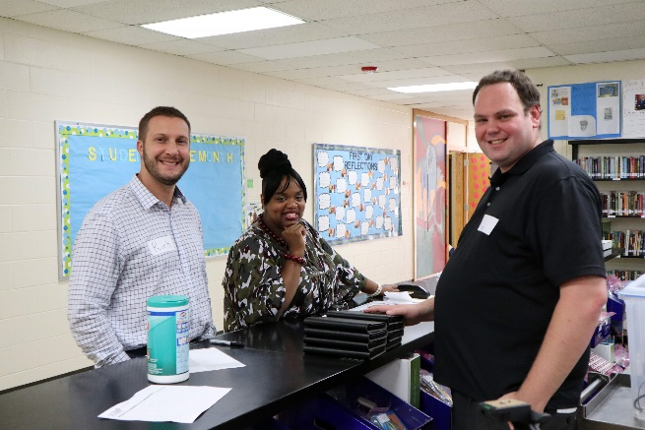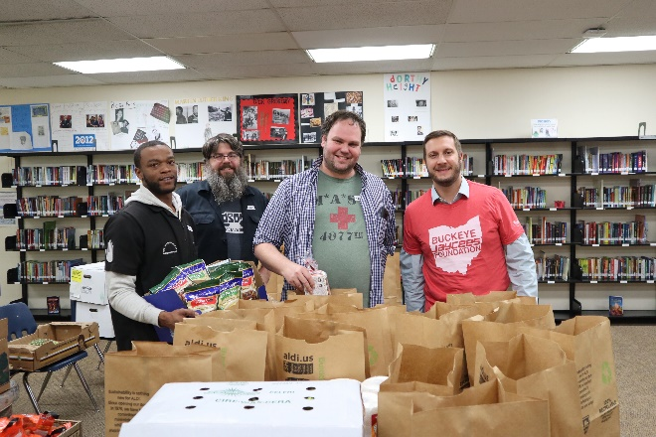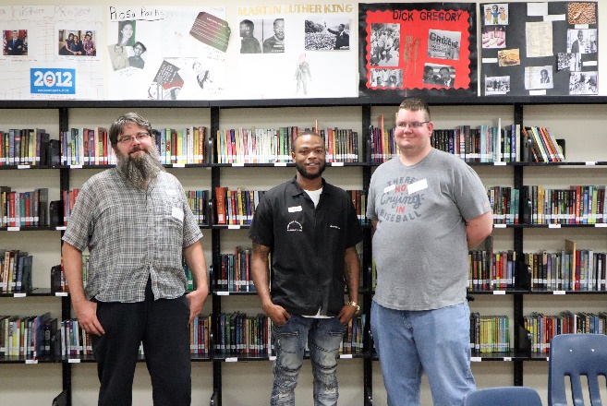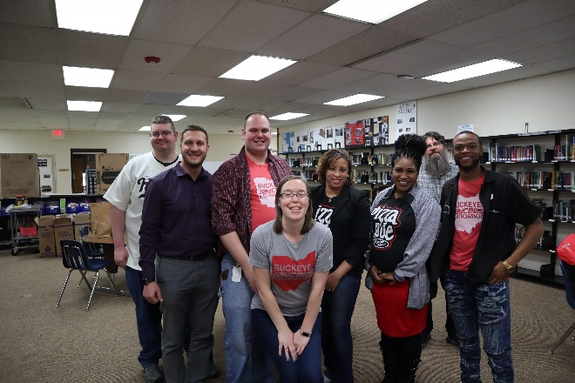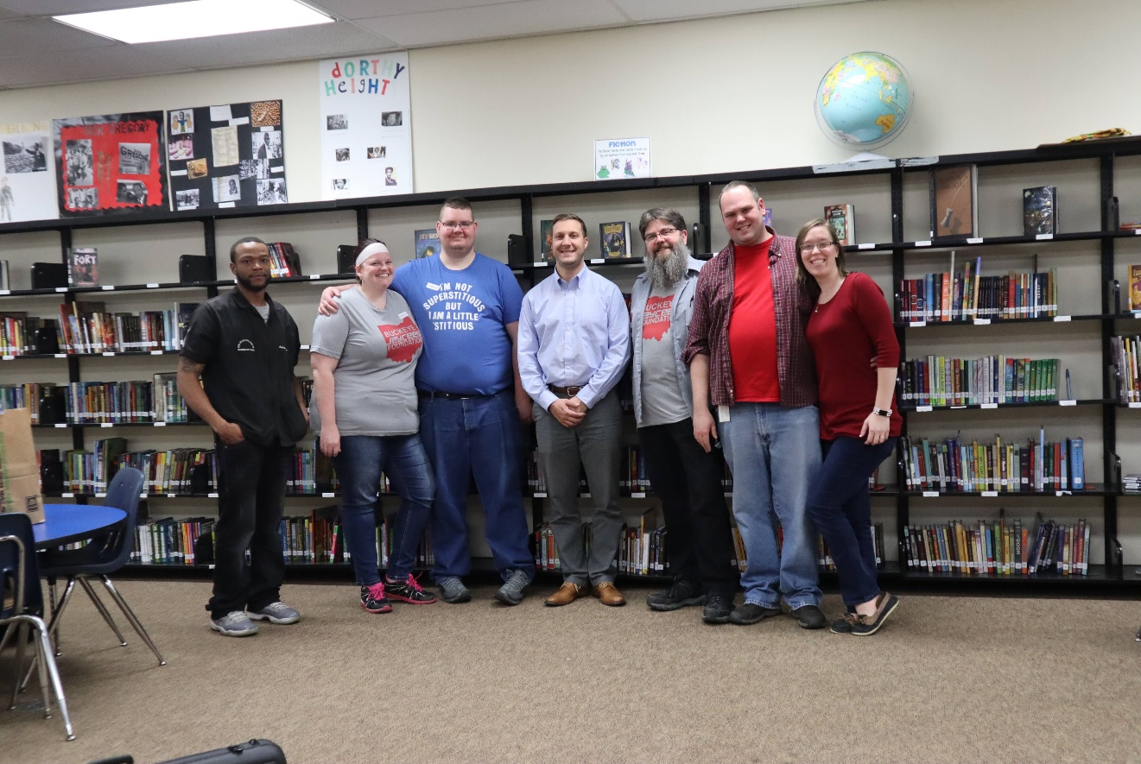

Students
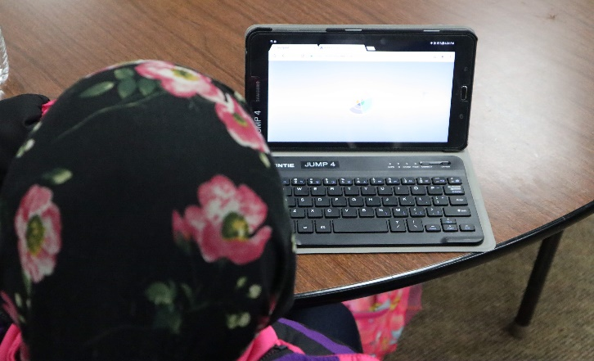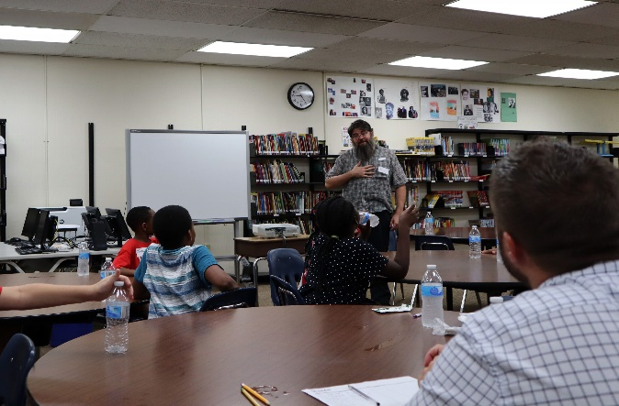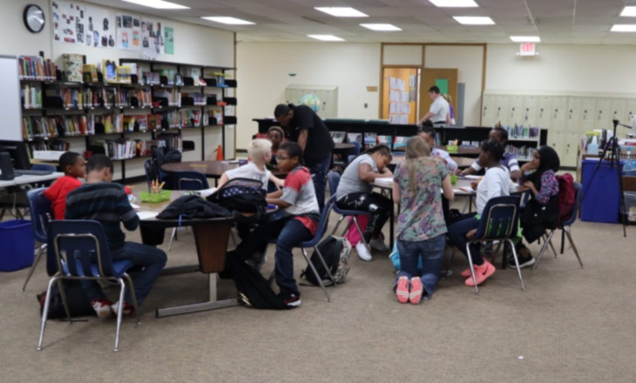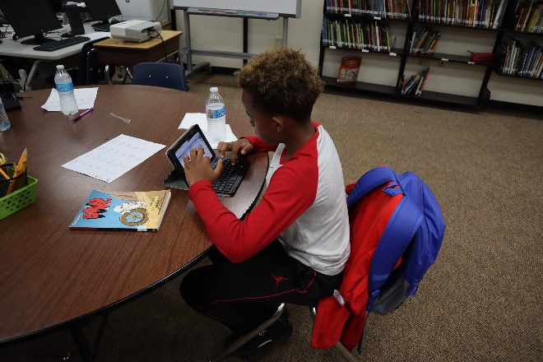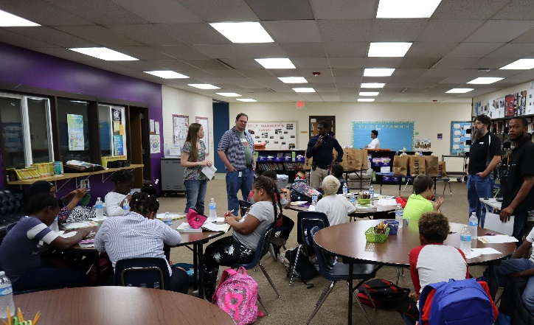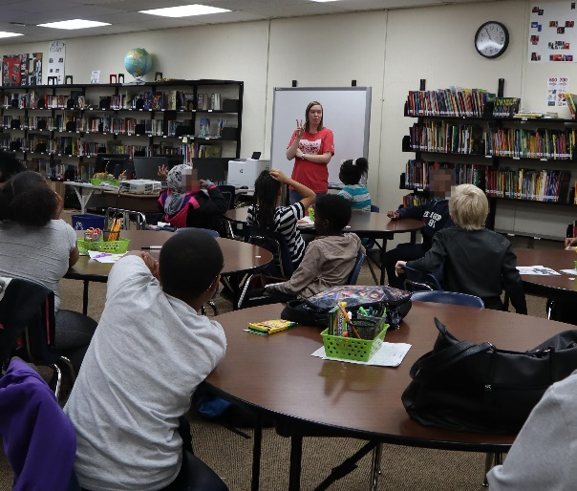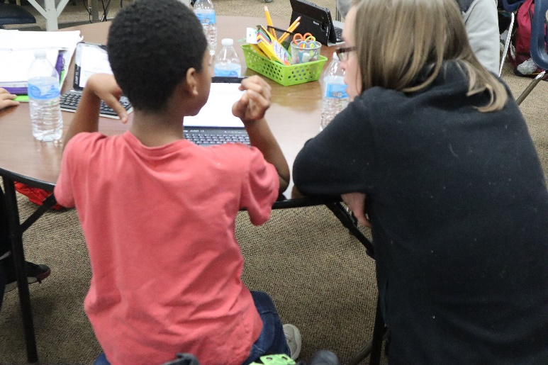

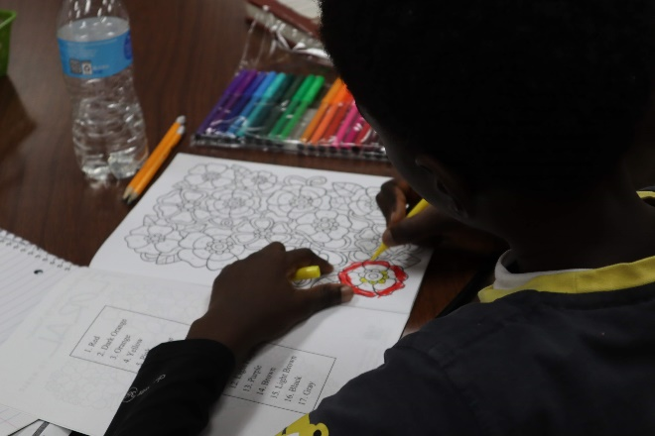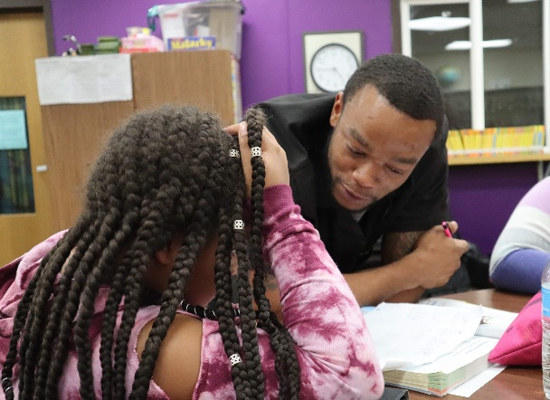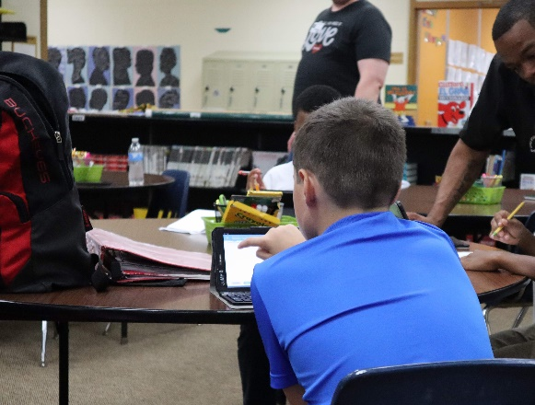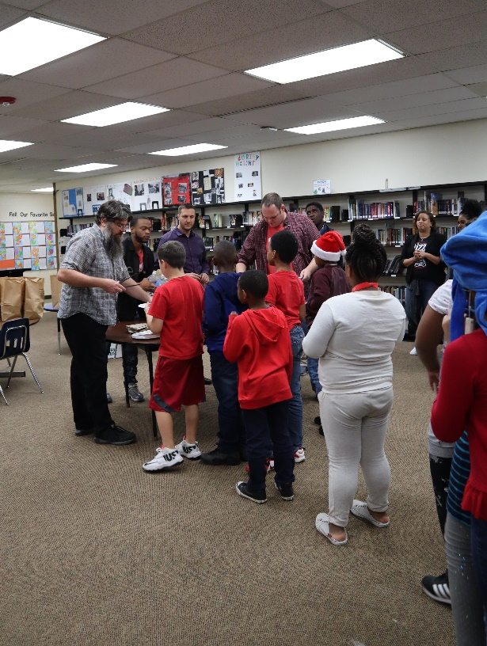

“Snack”
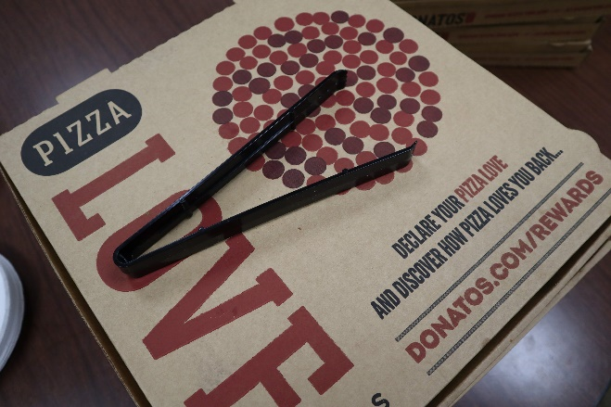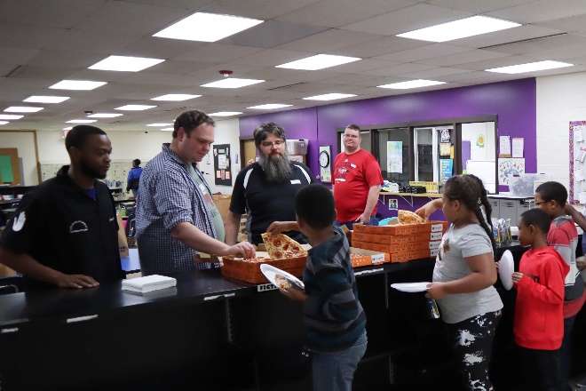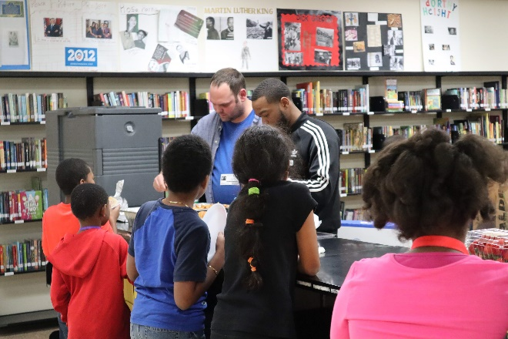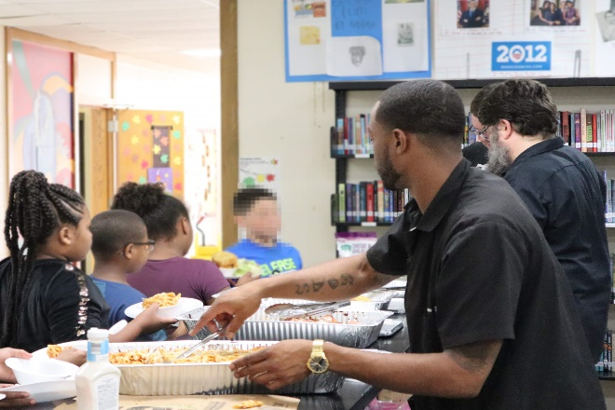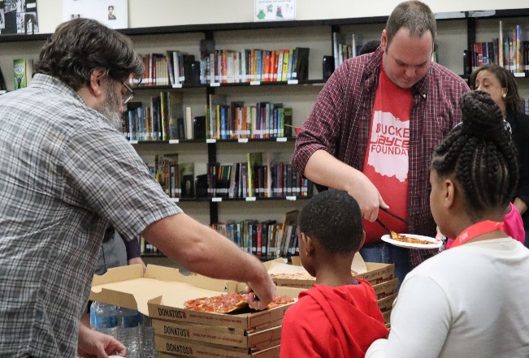

Food to take home
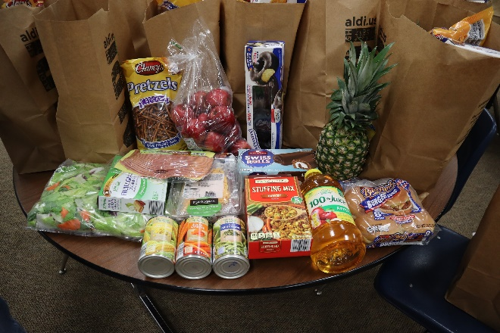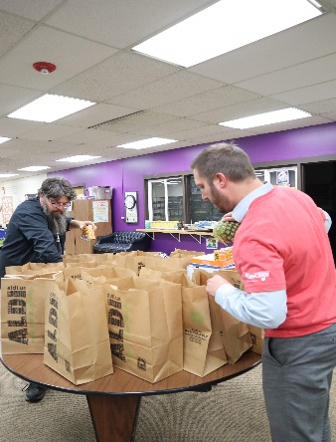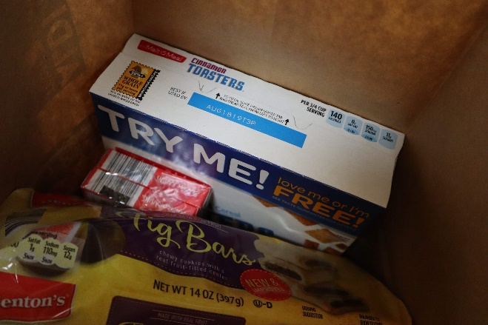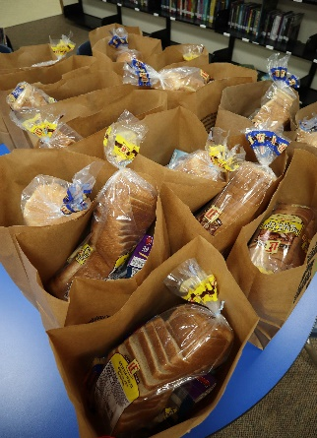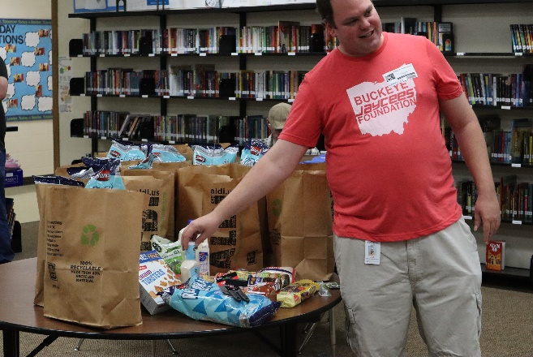

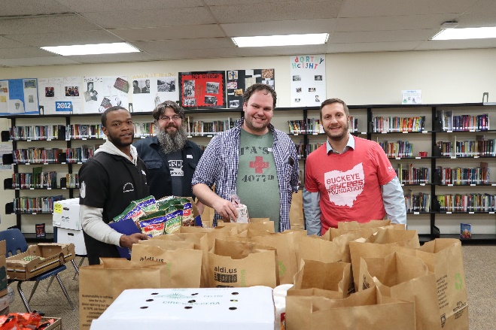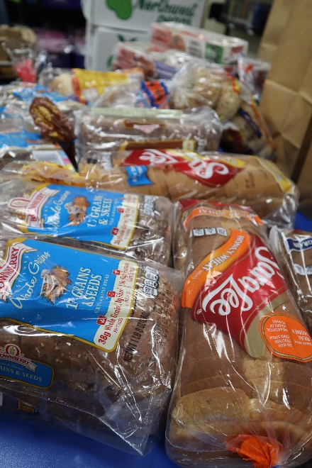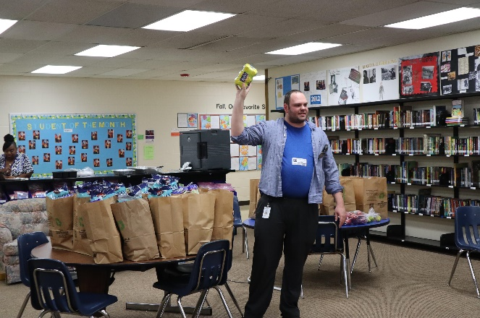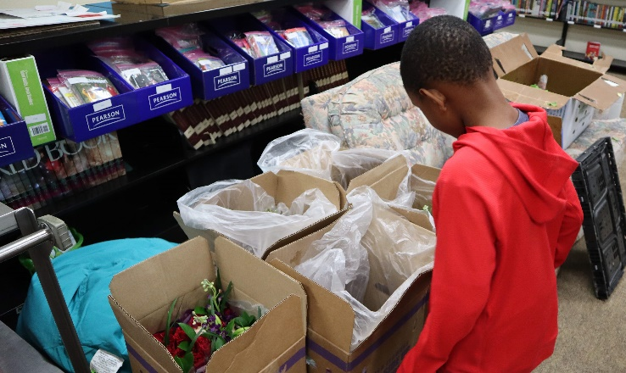

Secret Santa List
Name | Shakir
Age | 10
Favorite Color | Blue, Red, Black
Favorite Animal | Lion, Tiger
Favorite Team | Saints, Heat, Lions, Steelers,
Pant size | 12
Shirt size | 10.5
Shoe size | 6/7
One item under $20 | "Stikbot Toys"
Name | Carla
Age | 10
Favorite Color | Blue, Pink, Purple
Favorite Animal | Unicorn
Favorite Team | N/A
Pant size | Med (8-10)
Shirt size | Med
Shoe size | "Don't need shoes"
One item under $20 | Unicorn Pillow
Name | Brelin
Age | 10
Favorite Color | Blue
Favorite Animal | Black Panther
Favorite Team | N/A
Pant size | N/A
Shirt size | 10/12
Shoe size | 5 1/2
One item under $20 | 2 blue slime's from "5 and Below"
Name | Amarian
Age | 11
Favorite Color | Blue
Favorite Animal | Cheeta
Favorite Team | Ohio State
Pant size | 12
Shirt size | 10 to 12
Shoe size | 5 or 6
One item under $20 | X-Box gift card
Name | Xavier
Age | 10
Favorite Color | Yellow
Favorite Animal | Eagle
Favorite Team | Vikings
Pant size | 10
Shirt size | 10
Shoe size | 4
One item under $20 | N/A
Name | Jayden
Age | 10
Favorite Color | Blue
Favorite Animal | Snake
Favorite Team | Steelers
Pant size | 8
Shirt size | Large (7)
Shoe size | 3
One item under $20 | N/A
Name | Raymya
Age | 9
Favorite Color | Teal, Grey, White
Favorite Animal | N/A
Favorite Team | Ohio State
Pant size | N/A
Shirt size | 18 T
Shoe size | 8
One item under $20 | 2 Fannypacks
Name | Victoria
Age | 10
Favorite Color | Hot Pink
Favorite Animal | Panda, Tiger
Favorite Team | Cleveland Cavs
Pant size | N/A
Shirt size | "L/G 11/13"
Shoe size | 7 1/2
One item under $20 | "Hottaki Faniepack"
Name | Taysiir
Age | 10
Favorite Color | Blue
Favorite Animal | Panda
Favorite Team | Ohio State
Pant size | 9
Shirt size | 8
Shoe size | 2 1/2
One item under $20 | Ring, Takis, Unicorn pillow
Name | Euclid
Age | 11
Favorite Color | Blue
Favorite Animal | Lion
Favorite Team | Cowboys (NFL)
Pant size | 14/16
Shirt size | 12
Shoe size | 7 1/2
One item under $20 | Remote Control Car
Name | Caleb
Age | 10
Favorite Color | Green
Favorite Animal | Polar Bear
Favorite Team | Rams, Cavs
Pant size | Small
Shirt size | Small
Shoe size | 3.5
One item under $20 | N/A
Name | Marques
Age | 9
Favorite Color | Blue
Favorite Animal | Tiger
Favorite Team | Ohio State
Pant size | Large or XL
Shirt size | XL
Shoe size | 5
One item under $20 | WWE Action Figure
Name | Elijah
Age | 7
Favorite Color | Red
Favorite Animal | Dog
Favorite Team | Ohio State
Pant size | N/A
Shirt size | 8
Shoe size | 3
One item under $20 | Toy Car's, Shoes
Name | Elizabeth
Age | 10
Favorite Color | Rose Gold
Favorite Animal | Cheetah
Favorite Team | N/A
Pant size | N/A
Shirt size | XL
Shoe size | 8 1/2
One item under $20 | Giftcard for Clairs, Diary for girls

